NHJ-Q600C
FUSING MACHINE

INSTRUCTION
MANUAL

Reading the manual carefully before operating

Shanghai Weishi Machinery Co., Ltd
Add： 52 # No. 1089 Qinzhou, Road (N0 Shanghai China Post Code：200233
Telephone：86-21-64953003，64958277，64955983 Fax：64952757
I.SUMMARIZATION
NHJ-Q600C-type pressure-type hot-melt adhesive roll machine for clothing industry in the production of various types of hot-melt adhesive Fusible Interlining processing, especially for wool, thin-and-light fashion fabric adhesive and thermal reduced processing stereotypes. This machine is belt type continuous hot rolling process, using feedback received material feed units, and thus high productivity. The control system used to control programmable logic controller, which has strong adaptability and reliability
This model has the following characteristics:
1.Gas flow-controlled, pressure adjustable.
2.Electrical - mechanical with automatic devices. Low-speed synchronous motor control transfer with mechanical devices to ensure that the conveyor belt running trajectory fluoride levels in the normal position.
3.Electric heating plate for the drawn aluminum, durable non-deformation, and thus uniform temperature.
4.Synchronous upper and lower rotating bodies with spin-off.
5.Rack structure of the aircraft used to support the structure of single-sided wall panels rather than a closed cabinet and equipped with attachments for, the replacement of fluoride with machines than with the type of adhesive to facilitate,
6.Delay down 10 seconds after the power was automatically cut out.
7.Machine failure alarm.
The characteristics of the models, easy to operate, programmable logic control to ensure the reliability of the machine running and devices used in long-lived.

II.MAIN TECHNICAL SPECIFICATIONS
NO. | Main Items | Specifications
1 | Working width mm | 600
2 | Temperature control range 。C | Room Temperature —— 200
3 | Largest working pressure Mpa | 0.4
4 | Fusing tape speed m/min | 0 —— 10
5 | Total power kw | 6
6 | Power pressure | 220v±10％ / 50HZ
7 | Compressed air pressure Mpa | 0.5
8 | Dimensions L*W*H mm3 | 1880×1040×1100
9 | Net weight kg | 200

III.The mechanical structure
Of the mechanical structure of the feed part of rack, pressing part, transmission part, some of the material, such as control box and electrical parts. Mechanical structure see Figure (a)
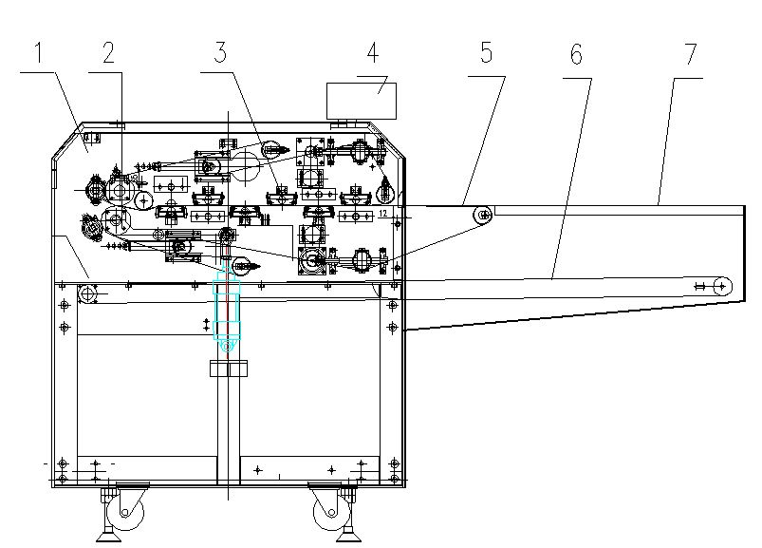
PIC（1）
1. Rack 2. Pressurization 3. Electric heater 4. To control the operation box
5.Loading 6 feed. Rack of 7. Feed Desk
Main drive motor for the Frequency Control, through the sprocket, chain and gear driven synchronous pressure after the club from top to bottom, so that conveyor belt to move the tetrafluoroethylene. Machine contains electrical heating plate 6, two upper and lower parts of sub-heating control. Pressure control by the regulator after the pressure of compressed air into the cylinder at both ends of stick to stick up and down pressure contact with the silicone rubber surface for rolling adhesion. Stick pressure process pressure can be requested to adjust the control panel. Spin-off of the machine equipped with a rotating body velvet belt roller device clearance.
Fourth, the machine is installed
1, at the bottom of the machine equipped with wheels, moving in after loading and unloading can be rolled directly to the scene.
2, the machine must be left around the location when sufficient space for machine maintenance and more
For conveyor belt. After positioning the machine should be corrected horizontal position, the specific methods used Gradienter tension axis and the pressure placed on the club level calibration, adjust the machine screw at the bottom of your feet up.
3, to connect single-phase 220V power supply (do not connect wires with less than 4 mm wire), the machine must be a good ground cover protection.
Connect compressed air gas source.
Electric Control Principle
NHJ-Q600C-type pressure-type hot-melt adhesive machine electrical control by the use of programmable logic.
Control part of the whole can be divided into the following sections:
Fluoride with 2 speed transmission, belt drive automatic adjustment of fluoride anti-bias control
3, heating temperature control, 4 fault alarm control 5, part of operational control panel

Electrical Diagram
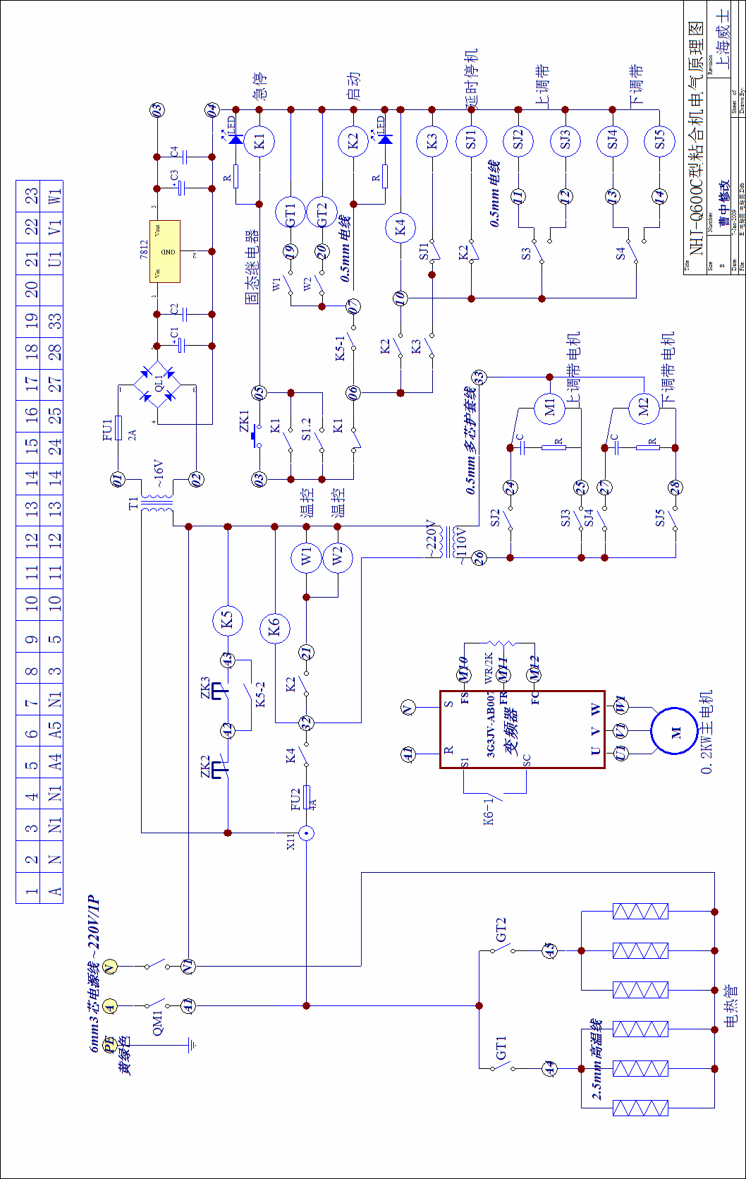

VI.The use of machine operators
Machine before the first start, first of all, each part of the machine to check the situation, whether there are loose connections, and the feed-in any foreign body between the conveyor belt, electrical wires inside the screws and wires to connect it has eased pressure in the provisions of range. In various parts of the machine to ensure that all normal plug in the power machinery. Start by running the following steps:
All electrical boxes on the side of the total power supply before the air switch.
Open the intake valves, to regulate the inlet pressure of about 0.4Mpa.
Adjust the control panel on the pressure, relax the pressure stick.
1, the start button to start running, 2,3-conditioning thermostat, set the required temperature
Temperature settings, the regulation of adhesion to the desired working pressure of the pressure 7. General work pressure in the 0.2-0.35Mpa around.
After all the normal machine, you can test the feed pressure processing.
Below is the electrical control board
1 2 3 4 5 6 7 8
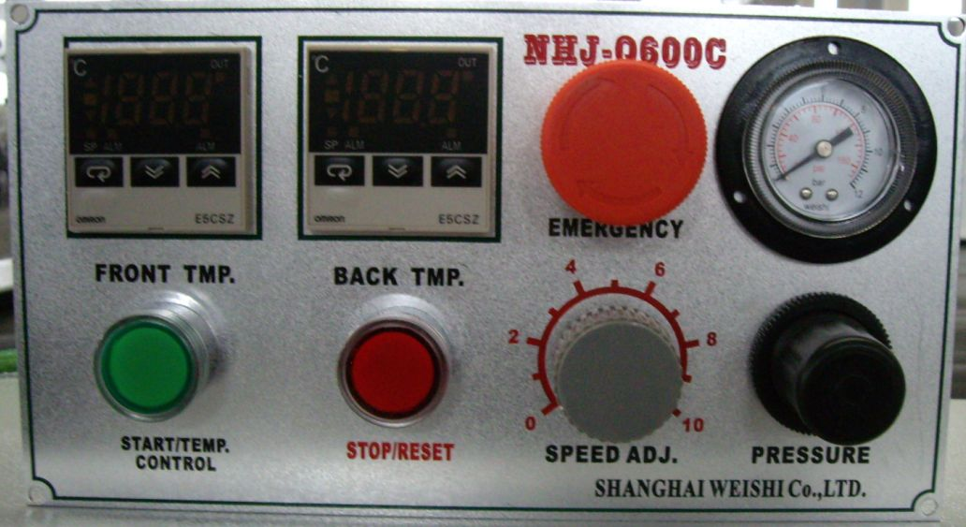
Pic 3 Control Board
- START 2、FRONT TMP. 3、BACK TMP.
4、STOP 5、EMERGENCY 6、SPEED ADJ
7、PRESSURE 8、PRESSURE METER

Bonding process, the user can Fusible Interlining and clothing in accordance with each of the different characteristics of pressure test, a reasonable regulation of temperature, speed and pressure, this three-factor adjusted to its best. Conditions and pressure test records archive tabulated for a variety of Fusible Interlining After processing the bulk adhesive.
Processing after the press delayed shutdown / alarm button 4, delay indicator light, machinery continues to run, but the heater will automatically cut off power, and the thermostat is still indicative of the current temperature, the time delay in the control of parking in part programmable logic controller settings, the factory set to 30 minutes.
Machine downtime in the delay state, as long as the start button again, the machine on the resumption of normal operation. Shutdown delay time when the machine will automatically shut down, running down the machine after 10 seconds, the total power supply is automatically cut off.
Delay shutdown heat also took the opportunity to take timely clearance and cloth painted with silicone adhesive and timely removal of dirt (if too much adhesive dirt in the boot in, please be sure to lower the temperature, reduce the pressure). Machines should be kept clean regularly, do not stay in the foreign body and feed conveyor on the work of the mouth.
Emergency shutdown when the machine or failure, will report to the police, the corresponding indicator light, troubleshooting, press the start button, the machine restarted.

VII, pneumatic control principle
NHJ-Q600-based hot-melt pressure-type adhesive bonding machine by the pneumatic pressure to control. Requirements of the gas inlet pressure in more than 0.4MP.

Pneumatic Diagram

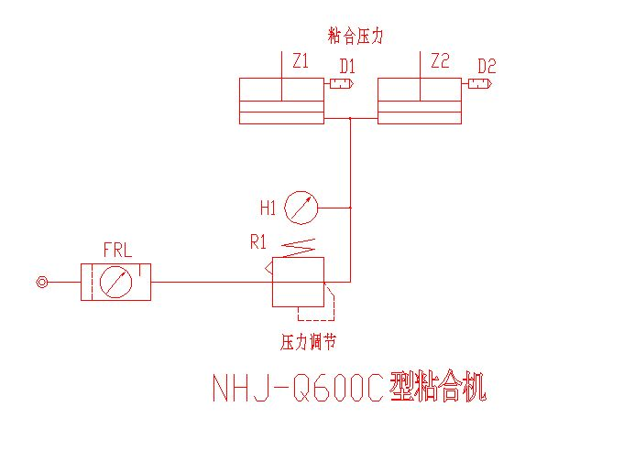

VIII. machine maintenance and adjustment and maintenance
In order to improve the life of the machine, with the exception of the right to the use of machinery, but also must be maintained. Under normal circumstances, the machine must be frequently note the following:
Fusible Interlining is not to be, but home, causing glue interlining up in the upper edge machine axis, the area has led to serious stranded hot melt adhesive, a long-term deformation caused by fluoride.
Fusible Interlining hot cut pieces should be slightly less than to prevent the hot melt adhesive area dirty.
2. The replacement of conveyor belt fluoride methods:
1, remove cap, casing around,.
2, removed with a spring up on both sides, carefully drawn up with roller, conveyor tetrafluoroethylene release.
3, removed the right side of upper and lower wall panels and rack screws and screw connections. Spring pressure off the right side, remove the right side of Block stop limit switch.
4, with attachments with support for up and down the right side wall panels, carefully taking the old belt, and then into a new belt, put the location of the opposite according to the order of assembly will be a good body.

 

NHJ-Q600-type bonding machine in the mechanical structure, control the way in some cases the user needs, a change in the actual machine, and a detailed description of differences between there, the Company will not otherwise stated, and reserve the right to interpret.

Packing list

Name of product | Unit | Quantity | Model No. |  | Serial No.
Case No. | Unit | 1 | NHJ-Q600C
Case No. | Dimension (mm) |  | Volume(m3) | Net weight(Kg) | Gross weight(Kg) | Notes

no. | Spare parts | Unit | Quantity | No. | Spare parts | Unit | Quantity
1 |  |  |  | 7
2 |  |  |  | 8
3 |  |  |  | 9
4 |  |  |  | 10
5 |  |  |  | 11
6 |  |  |  | 12

no. | Technical document | Unit | Quantity
1 | Operational manual | Piece | 1
2 | Certificate | Piece | 1
Inspector Packer Date of packing

CERTIFICATE OF QUALITY

Model No. NHJ-Q600C

Name: FUSING MACHINE

Serial No.

This machine has been successfully inspected and is allowed to sell

Inspector: Dean: Principal:

Date: Year Month Day

